**Definition: Design interesting techniques with Blending Modes in Figma.**

**Solution:**

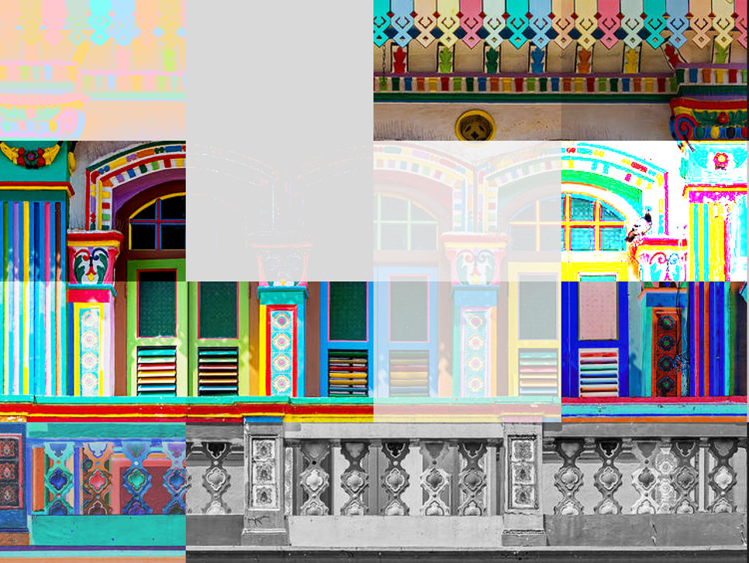

**Steps:**

* First Open Figma in browser mode.
* Then create the new document **File à New Figma Design.**
* Now take an image of width=**”750px”** & hight=**”560px”**.
* Draw 16 Rectangle of width=**”188px”** & hight=**”140px”**, now give every rectangle following layers.
* Normal
* Darken
* Multiply
* Color Burn
* Lighten
* Screen
* Color Dodge
* Overlay
* Soft Light
* Hard Light
* Difference
* Exclusion
* Hue
* Saturation
* Color
* Now, Go to the Export button in the property panel. And Export it with .JPG/.PNG format.